**Future City Scan**

Populated will decline by 7% to 4,212,630 in 2100 under SSP2. Under SSP5 it will decline by 3,097,355 22%.

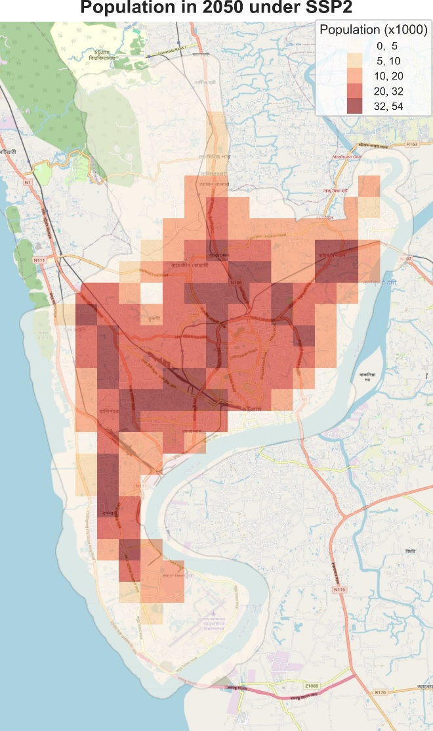 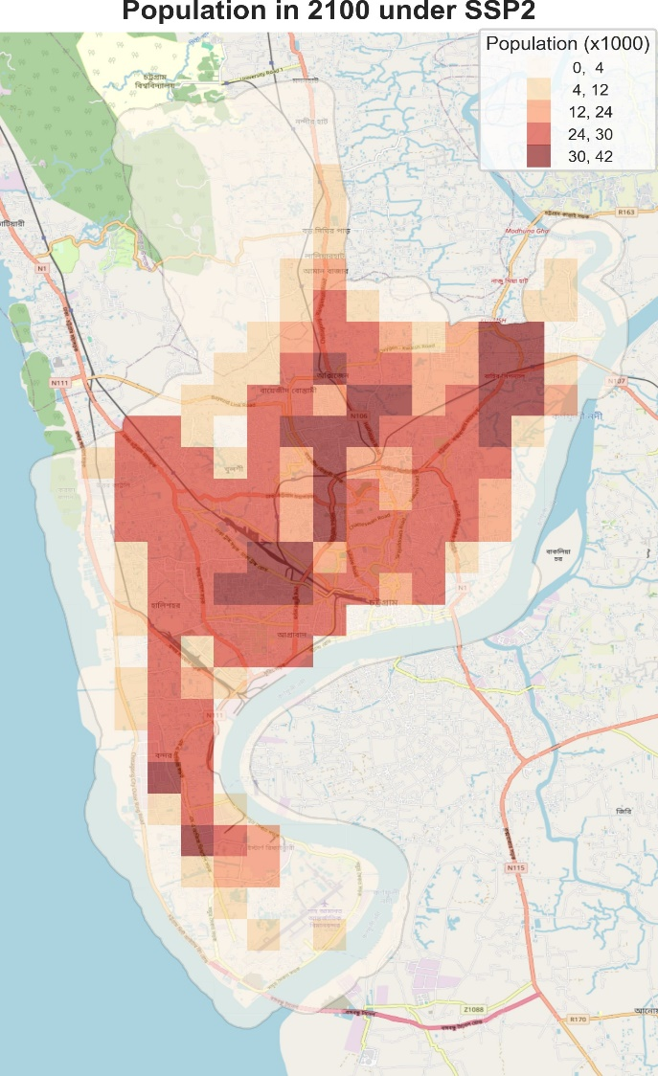

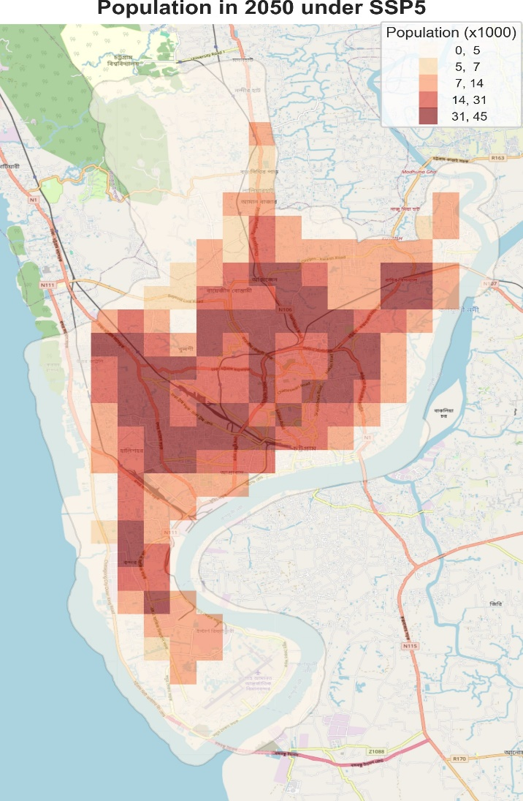 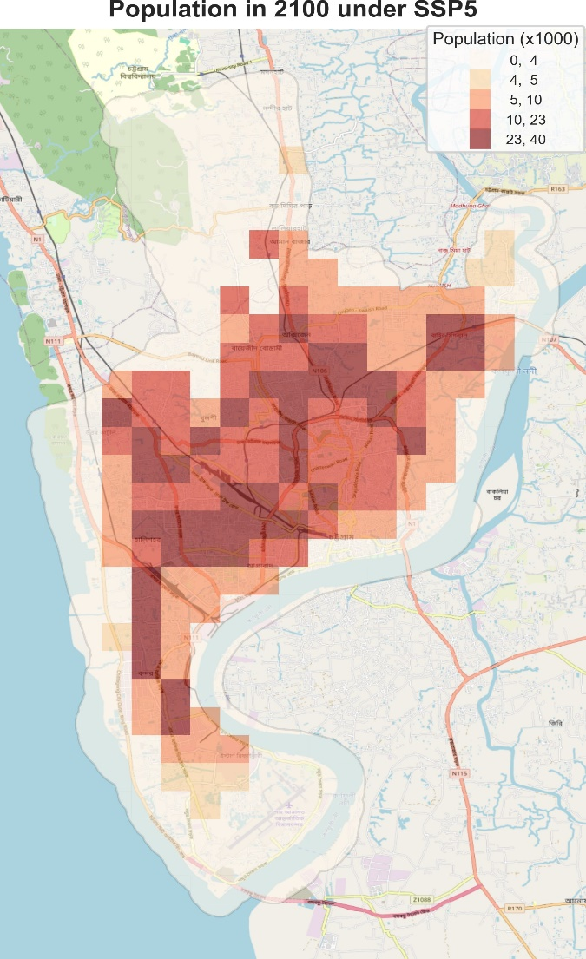

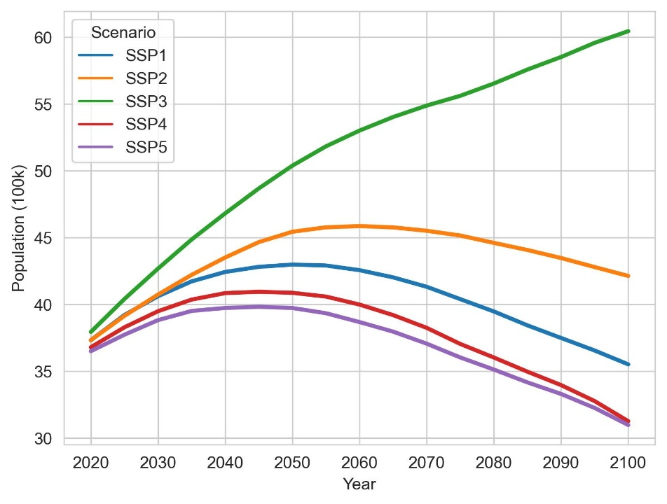

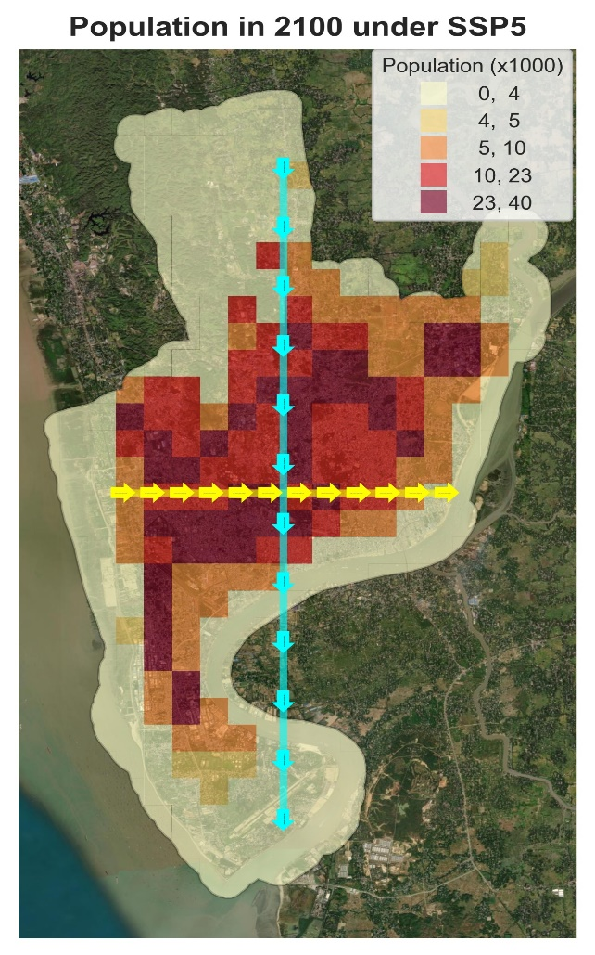

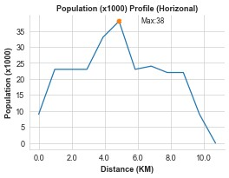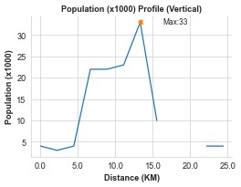

Most of the population in concentrated in the core of the city. Variation in the city can also be seen from a horizontal and vertical cross-sections of populations. The cross-sections show that the dense area pixels are inhabited by 38 thousand people.

Currently the Amenities are distributed unequally and this inequity will amplify with time.

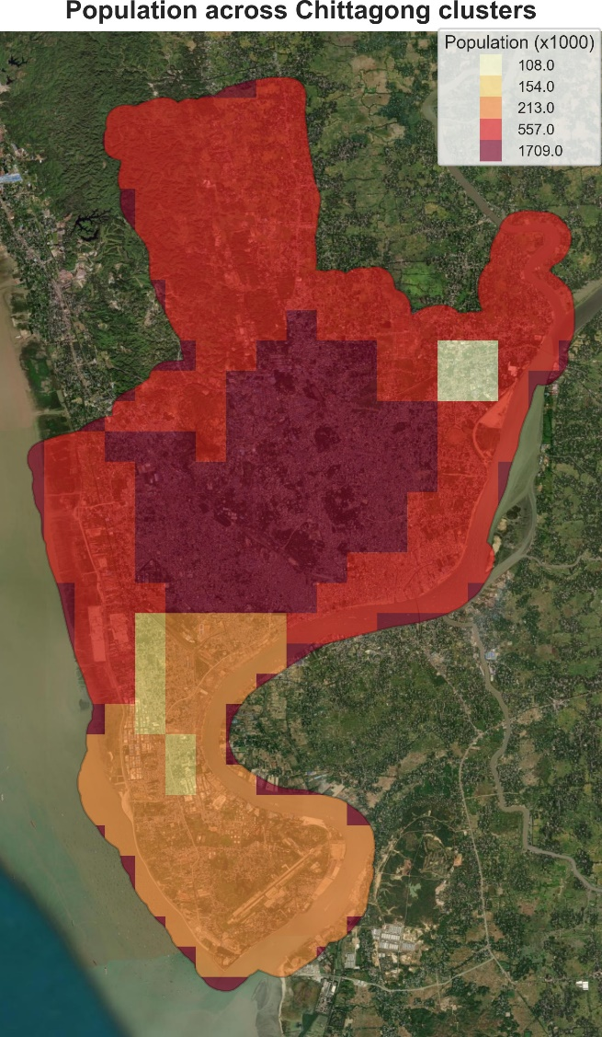

|  |  |  |  |  |  |  |
| --- | --- | --- | --- | --- | --- | --- |
| **Cluster ID** | **Cluster Location** | **rank** | **Population density** | **Parks** | **Educational facilities** | **Industries** |
| 1 | Center | 1 | 16.32 | 30 | 289 | 7 |
| 7 | west | 1 | 16.32 |  |  |  |
| 0 | north | 2 | 5.45 |  |  |  |
| 3 | west | 2 | 5.45 |  |  |  |
| 4 | south west | 3 | 1.68 |  |  |  |
| 6 | south | 3 | 1.68 |  |  |  |
| 2 | south | 4 | 1.6 |  |  |  |
| 5 | north east | 5 | 1.16 |  |  |  |

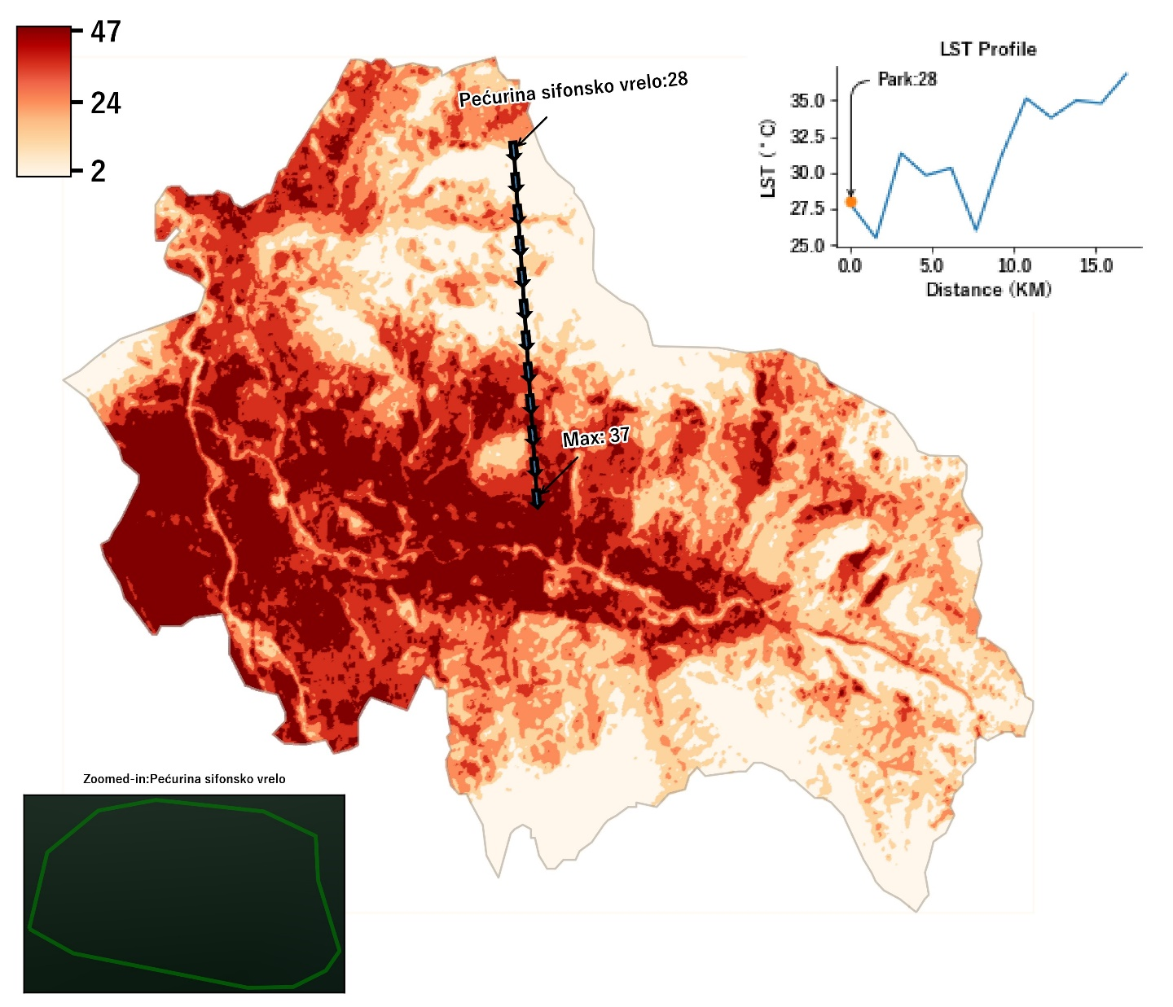

Get Fathom 3.0 and use that for next the iteration.

Calculate changes in rasters. Include their maps.

Run all approaches for all sections.

Update the SSP 3 data. Pop and GDP will be updated. Modify the code.

Fathom will be josted on Azure. Figure out a way to pull it. Write a function for that.

Use subcity Union council data to overlay and identify the max pixel overlap.

Create classes for change: drastic extreme etc.

Zonal stats stats at union council level and upzilla level for each section.

Review City scan graphs